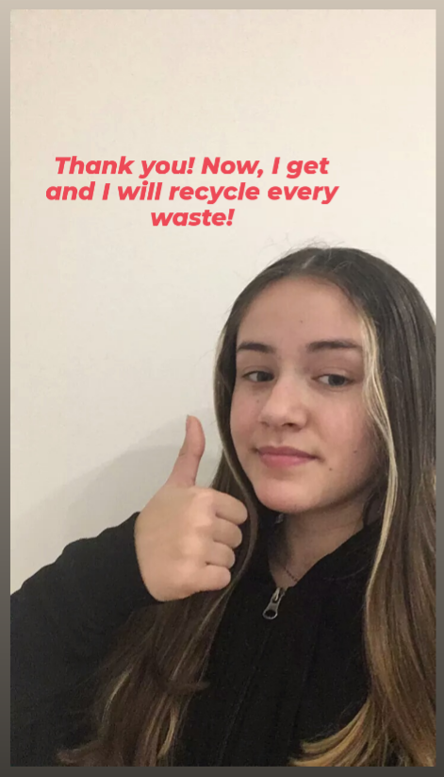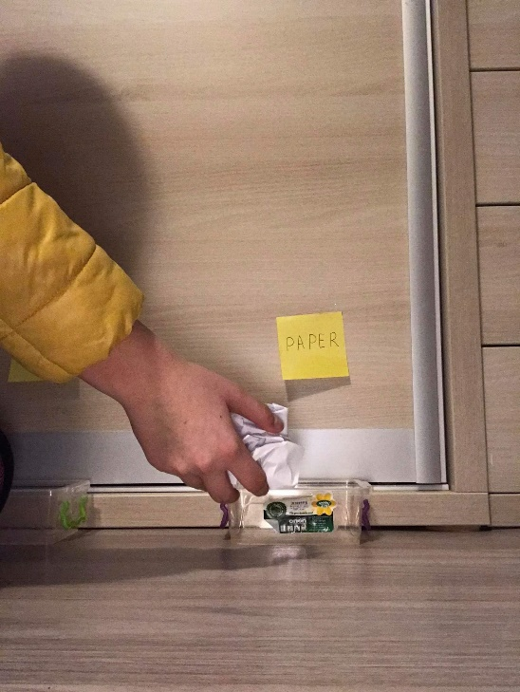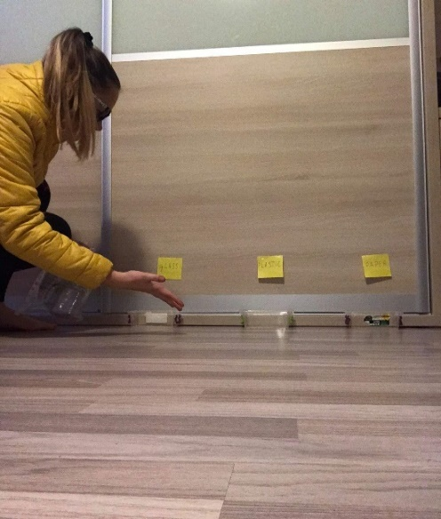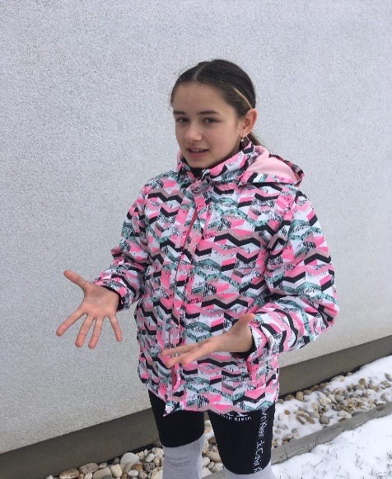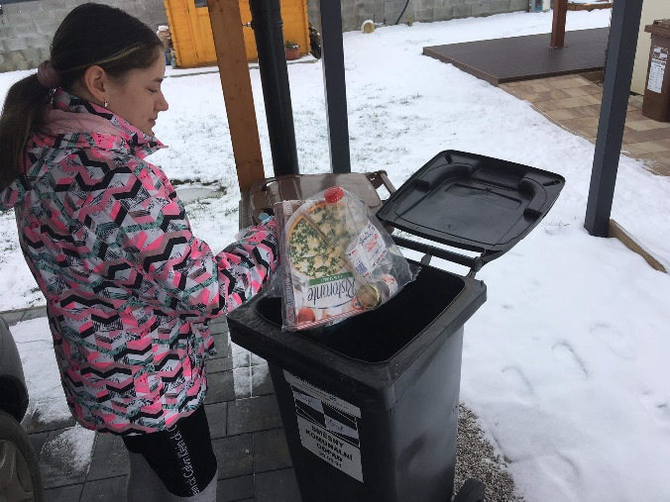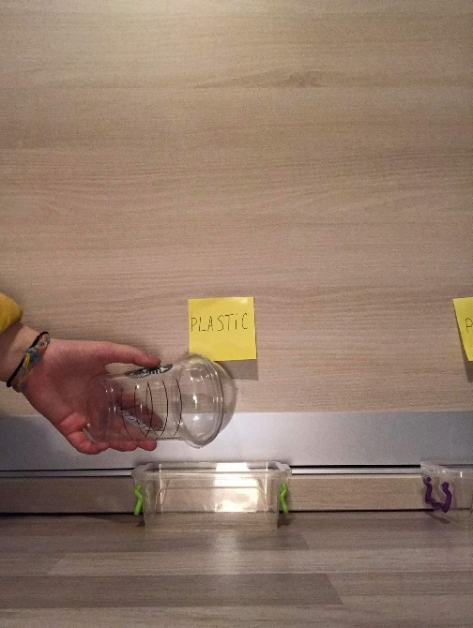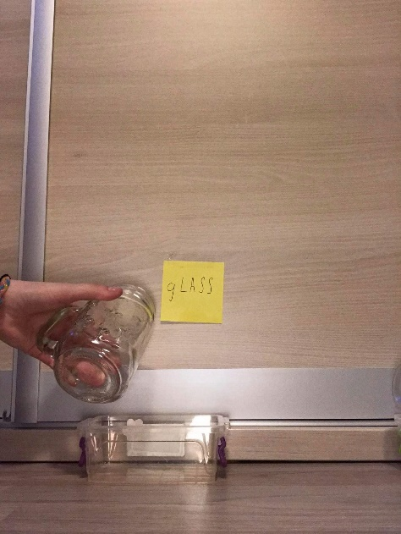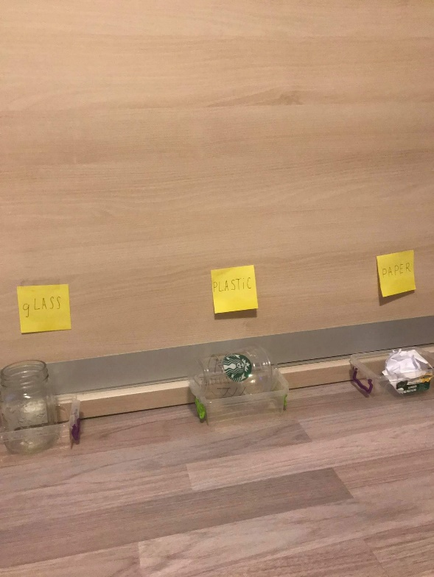

I’m gonna put it here.

Thank you! Now I get it and I will recycle every waste.

And this used paper goes into the paper container.

Recycling is very important for the Earth. It is about putting different waste into different containers.

For example, this old cup is made of plastic, so you put it into the plastic container.

Or this glass cup is made of glass, so it will be in the glass container.

No, you can’t put it there, you should try recycling!

Recycling? What is it? And why should I try it?